The Muffin Method

- The pan should be placed on the rack in the of the oven.

- A preheated oven is important so the product can be baked at an
temperature.
- The appearance of the muffin batter should be when finished mixing.
- What causes tunnels in muffins?
- Name 2 other baked products that can be made using the muffin method.
  - . b. .
- The two main methods of testing for “doneness” are:
  - Insert a toothpick into the center of the product and it comes out

  - When the product is touched with the forefinger it should:

- When Susie’s muffins came out of the oven, they had a very smooth top appearance and there were large tunnels inside the muffins. Explain why.

- Jennifer was given the following ingredients to make pancakes:
1 ½ c. | 375mL | Flour
¾ tsp. | 3mL | Salt
3 Tbsp. | 45mL | Cooking Oil
1 | 1 | Egg
2 tsp. | 10mL | Baking Powder
2 Tbsp. | 30mL | Sugar
1 ¼ c. | 310mL | Milk

But there were no directions given with the ingredients. Can you help Jennifer? Explain how you could combine the ingredients to make the pancake batter.

- Matching below match up the name of a type of flour to the description based from what we learnt on the demonstration day of banana chocolate chip muffins.

- . Whole Wheat Flour | - This type of flour contains very little gluten  - This flour is primarily made up of the endosperm.  - This flour is low in gluten because we don’t want our product to be tough  - This flour is super stretchy  - This flour is primarily made up of bran.
- . Cake Flour

- . Bread Flour

- . Rice Flour

- . All Purpose Flour

Parts of a cereal Grain
Flour is composed of up cereal grains.
3 components:
- Bran: Non-digestible carbohydrates known for its cellulose and fiber.

- Endosperm:

- Germ: powerhouse most nutritious part of the wheat kernel, contains fat, which becomes rancid at room temperature. The germ also contains iron.

This component of the cereal grain is usually removed to ensure that bread lasts longer. .

Muffin Method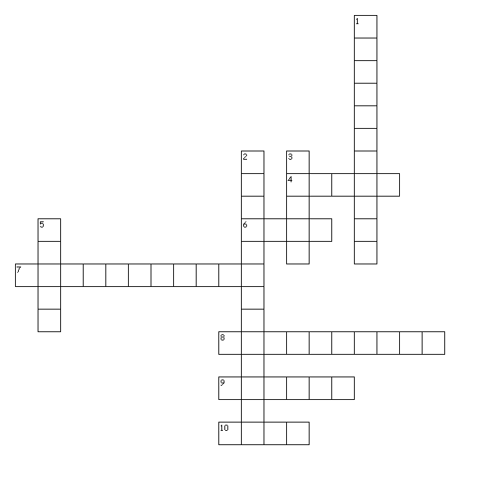
Across
4. When mixed properly the batter should look this way
6. Non-digestible carbohydrate
7. The colour of muffins when baked
8. Muffins are an example of this type of flour mixture
9. Location where the pan should be placed in the oven
10. The component removed from bread to prevent the bread from becoming rancid
Down
1. Utensil used to stir muffin batter
2. The gas produced by baking powder
3. Using a toothpick to check for doneness
5. Basic ingredient which provides the structure of quickbreads

