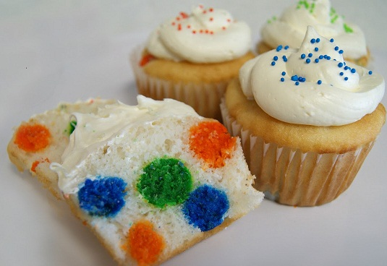
Polka Dot Cupcakes

Yields: 12 cupcakes

Batter for Polka Dots

½ cup. | White sugar
¼ cup | Butter
1 | Egg
1 tsp. | Vanilla
¾ cup. | All-purpose flour
1 tsps. | Baking powder
¼ cup | Milk

Directions:
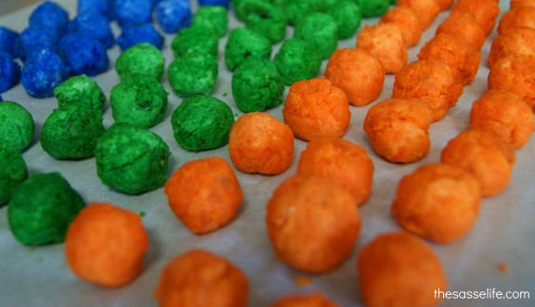
- See below for making the batter

2. Divide the batter into three different containers, add food colouring to each. Place into baking pan and bake for 10-15 minutes. Once baked allow time to cool and then roll into little balls. Place two balls into the bottom of each cupcake holder. Pour on some batter and then add more balls. Repeat with another layer, and then top it off with cake batter

White Cake Batter
1 cup. | White Sugar
½ cup. | Butter
2 | Eggs
2 tsps. | Vanilla
1 ½ cups | All-purpose flour
1 ¾ tsps. | Baking powder
½ cup. | milk

Directions
- Preheat oven to 350 degrees F (175 degrees C). Line a muffin pan with paper liners.
- In a medium bowl, cream together the sugar and butter. Beat in the eggs, one at a time, then stir in the vanilla. Combine flour and baking powder, add to the creamed mixture and mix well. Finally stir in the milk until batter is smooth. Pour or spoon batter into the prepared pan.
- For cupcakes, bake 20 to 25 minutes. Cupcakes are done when it springs back to the touch.

