Gou Tie (Pot Stickers)
DAY 1:

Filling:
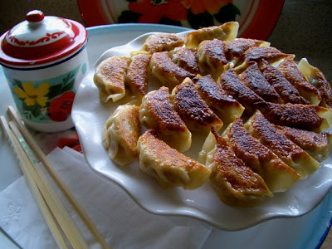
½ lb | Pork with Fat (Pork Rib, pork shoulder, pork belly)
½ lb | Cabbage
2 | Green onions
1 Tbsp. | Rice Wine or Dry Sherry
1 Tbsp. | Sesame oil
1 Tbsp. | Soy Sauce
1 tsp | Salt
1 Tbsp | Cornstarch
½ cup | Chicken or Pork Stock

Directions:
- Separate cabbage leaves and blanch in boiling water for about two and a half minutes. Allow to cool.
- Meanwhile, chop the pork with a cleaver, rolling the mass and varying the direction of the chop: this is a matter of personal preference, since finer mincing produces a more tender, “grainy” homogenous filling, while a larger mince, say, 3/16” to 1/4” will be somewhat more firm and varied in texture. You can also put the pork through a meat grinder, using a quarter inch plate.
- Place chopped meat in a bowl. Wring out the water from the blanched cabbage using a kitchen towel, and chop to 1/4" to 1/2" pieces. Mix this together with meat and all remaining filling ingredients, adding cornstarch last.
- Add chicken or pork stock slowly as you mix the filling in one direction. Continue adding stock until mixture is visibly wet and "sloppy." If you've overdone the addition of liquid, and the fillng is impossible to handle when making the dumpling, add more cornstarch to firm it up.
- Keep in mind that the filling will firm up when it is refrigerated. Covered, the filling can be refrigerated for up to five days. When you are ready to fill the dumplings, make one and boil it to test the flavor and texture, and making any adjustments at that time.

Wrappers:

Cold water can be used, but hot water dough produces a softer, more elastic dough, which is preferable in making most dumplings.

500mL | Bread flour, sifted
175mL | Boiling Water
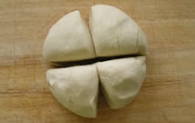
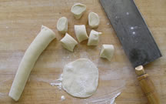
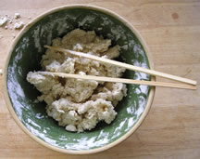

Directions:
- When water just comes to a boil, slowly add it to the sifted flour and mix with chopsticks until a crumbled paste forms.
- Knead the dough on a floured board as soon as it is cool enough to handle. Add flour as necessary to form a soft, elastic dough which is not too sticky to handle.
- Wrap with a damp cloth or plastic wrap and set aside to rest for about an hour.

Day 2:
- Divide the dough in quarters, and roll each quarter into a rope approximately 1” in diameter. Cut these into segments of about 5/8”, flatten with the palm, then roll out into a disk approximately 3” to 3-1/2” diameter, and 1/16” to 1/8” thick.
- Keep all dough and rolled skins covered to prevent drying. As I said, the skins can be purchased or the dough kneaded and rolled with a pasta machine, but texture and tradition will be sacrificed.

Assembly:
- Place a circle of dough flat in your left hand. Moisten the edge all the way around with water, then using a spoon or chopsticks, place approximately a tablespoon of filling in the center
- Fold the skin, and before the edges touch, grasp them with your right thumb and index finger, and beginning at the fold, pleat the outside edge, guiding the dough with your left fingers and press it to the inside
- As you do this from right to left, you will create a dumpling, which, when set aside on a piece of parchment paper or floured board, will form a flat side perfect for browning when making potstickers.

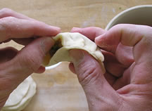
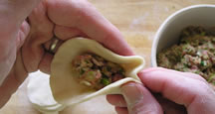
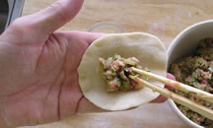
Cooking:
- Pre-heat a flat bottomed, well-seasoned pan or skillet on medium heat; add oil to a depth of approximately 1/16 inch.
- Arrange guo tie close together with the flat side of the dumpling in the oil.
- Cover and cook for about 3 minutes; after a couple of minutes, lift one or two of the dumplings to see how the browning is progressing. Add water to a depth of about 1/8”—be careful, this will spatter.
- Cover again and turn heat down to low or medium low, for about 4 minutes. After the potstickers are well steamed, uncover and cook for another two minutes, to evaporate any remaining water and to re-crisp the dumplings. Remove dumplings to a platter, and serve with browned sides facing up.

This minutely detailed first recipe for pot stickers and jiaozi is only for those who, like myself, consider eating dumplings as something like a religious experience.

A few years ago in the United states, when asked to name a Chinese dish, most people would say, chow mein or lo mein. The less savvy might have said chop suey, egg fu yung or egg rolls. But today, the best known item on Chinese menus is probably pot stickers, or as they are known in Mandarin Chinese, guo tie. These fried pork dumplings are so common that even grocery store delis have sad, damp heaps of them in warming pans, alongside roast chicken and kielbasa. (In a more global sense one might think of dumplings as a gastronomical archetype, since stuffed doughs can be seen in just about every culture: raviolis, perogies, knishes, empanadas, samosas, knodels, vushka, pelmeni, Korean mandu...the list is endless) Less famous in the west is the steamed or boiled—and most likely original—version of this dumpling, jiaozi, which is a mainstay of Chinese cuisine. In fact, jiaozi are at the heart and soul of Chinese culture. No other food, with the exception of rice and noodles, has a more prominent place in the everyday lives of Chinese: they are a snack, a staple, a holiday treat, and an almost sacred ritual around the Lunar New Year. During this time, making jiaozi is a social ritual as well, with family and friends gathering round the bowls of fillings and dough, rolling skins, stuffing the jiaozi and talking, until hundreds of the little morsels are ready for boiling.

There is no such thing as an “authentic” Chinese recipe, since within China there is no agreement on how any particular dish should be made. In China, jiaozi and guo tie are made with beef or pork; they sometimes have fresh shrimp, dried shrimp or no shrimp at all; you’ll find dried mushrooms in some, but not in others; sometimes cabbage, sometimes not. But in general, the tradition of these dumplings include the ingredients and methods outlined here.

As far as wrappers are concerned, acceptable factory made skins for making jiaozi and guo tie are available at all Asian groceries. Also, home cooks can take the recipe below and process the skins with a pasta machine, cutting the sheets of dough with an appropriate sized circle cutter; however, the homemade, hand-rolled hot-water version is closest to the traditional Chinese method, and worth the effort in its superior texture: it will be substantial, flavorful and chewy.

About the meat: fatty cuts of meat are not demonized in China as they are in the west; traditional cooks will most often use ground pork belly, here commonly called fresh bacon. On Chinese streets, you will find vendors selling ground pork for dumplings which is nearly white with fat. In the present recipe, the cut of pork is optional, and a even lean meat will make an acceptable dumpling.

